TimeSprite

System Design Document

University of the Pacific

COMP 188, Senior Project, 2015 Fall ---Yunpeng Zhang

Contents

0

2 SYSTEM ARCHITECTURE 2

3 Hardware, Software and System Requirements 3

4 External Interfaces 4

5 Software Design 5

5.1 UML Class Diagram 5

6 User Interface Design Sketches 6

6.1 Interface Sketches 6

7 Glossary of Terms 7

8 References 8

# SYSTEM ARCHITECTURE

TimeSprite will run on iPhone and iPad device, and require iOS 9.0 system or above. Also, for back up events, users may want to use their iCloud account to upload calendar events to iCloud server.

# Hardware, Software and System Requirements

|  |  |  |
| --- | --- | --- |
|  | Requirements | Recommend |
| Device | iPhone 5, iPad 2, iPad Mini, or newer | iPhone 6s, iPad Pro, iPhone 6s Plus |
| System | IOS 9.0 or newer | IOS 9.3 |

Because TimeSprite is an iPhone Application, so all apple device can run IOS 9.0 or newer system version can run TimeSprite.

# External Interfaces

There is no external Interfaces for TimeSprite.

# Software Design

## UML Class Diagram

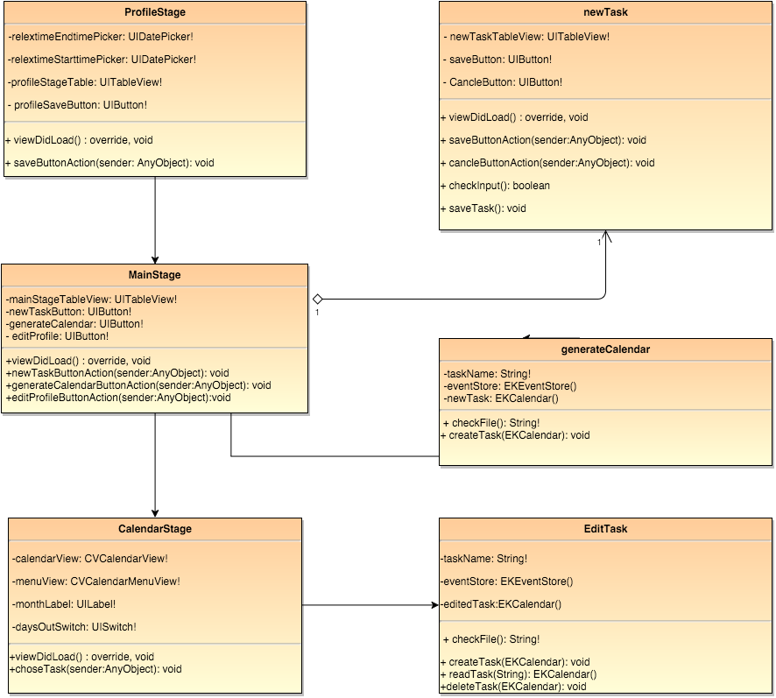

# User Interface Design Sketches

## Interface Sketches

*(See Requirements Analysis Document, Part 5 User Interface Design Sketches.)*

# Glossary of Terms

1. Pomodoro: The Pomodoro Technique is a time management method developed by Francesco Cirillo in the late 1980s. The technique uses a timer to break down work into intervals traditionally 25 minutes in length, separated by short breaks. (Wikipedia, 2015)
2. Stage: Stage in this project means each view controller in Apple App. Each user interface screen defines each stage.
3. Unavailable time: Set by user. Unavailable time means in this period TimeSprite will not sign any tasks.
4. Busy Time: Busy time means in this period, there are events already sign by system calendar.

# References

The Apache Software Foundation. (2004, January). *The Apache Software Foundation*. Retrieved from Apache License, Version 2.0: http://www.apache.org/licenses/LICENSE-2.0.html

Wikipedia. (2015, October 3). *Pomodoro Technique*. Retrieved from Wikipedia: https://en.wikipedia.org/wiki/Pomodoro_Technique